**Travel Agent as a Search Problem**

A travel agency is a public service providing the public with travel and tourism-related services on behalf of hosting or travel suppliers. In our case, we have developed a travel agency to find the best way to go from one city to another, reducing the time Using A * algorithm.

**System Component**

1. **Input Function, which User Deal with**
   1. print_solution (travel (From, To, Duration))
2. **Search Algorithm (A*)**
3. travel (From, To, Duration, Cities, List)
4. travel (Opened, Goal, Days, Cities, Closed, Result, LastTravel)
5. **Get State Node Children**
   1. gitAllChildren (CurrentState, Goal, Opened, Closed, Days, Children)
   2. getAllChildren (ListOfFlights , Goal,Parent,Tem,Res)
   3. getAllFlights (Start, Days, Opened, Closed, NewRes)
   4. getFlights (Start, Days, Opened, Closed, Res)
   5. getFlights (Start, End, Information, Days, Opened, Closed, Res)
6. **Get Days in a specific duration** 
   1. getDays ([Start, End], Days)
   2. getDays (Index1, Index2, Weak, [ Days])
7. **Calculate Time (g)** 
   1. g (Hour1: Minute1/ Hour2 : Minute 2/_/Day1, Hour3: Minute3/ Hour4 : Minute4/_/Day2, G, NG)
   2. getG (Hour2, Minute 2, Hour3, Minute 3, Hour4, Minute 4, Day1, Day2, Res)
   3. convertToMinutes (Hour, Minute, Res)
8. **Calculate Heuristic (h)**
   1. h (City1, City2, Res)
   2. loc (City1, X1, Y1)
9. **Calculate Summation of (g + h)** 
   1. f (H, G, Res)
10. **Get Min Node from List and Remove it** 
    1. gitMin (Opened, Min, NewOpend)
    2. gitMinFun (Temp, List, Min)
    3. remove ([List, Element, Temp, Res)
11. **Output** 
    1. printSolution (List, Count)
    2. getSolution (List, LastTravel ,Tem, Res)

**Our Knowledge (input file):**

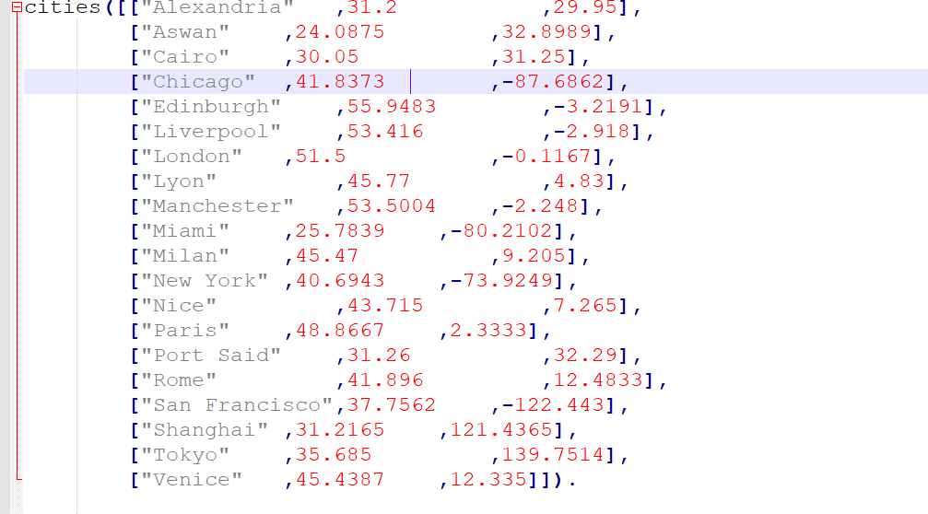

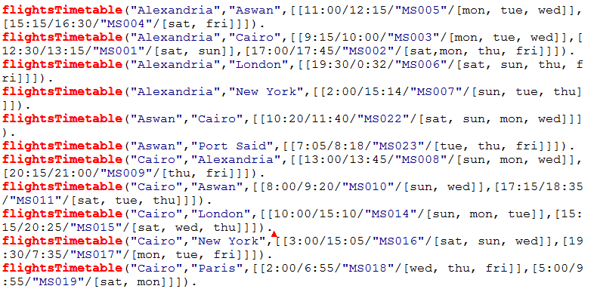

**Test Case 1:**

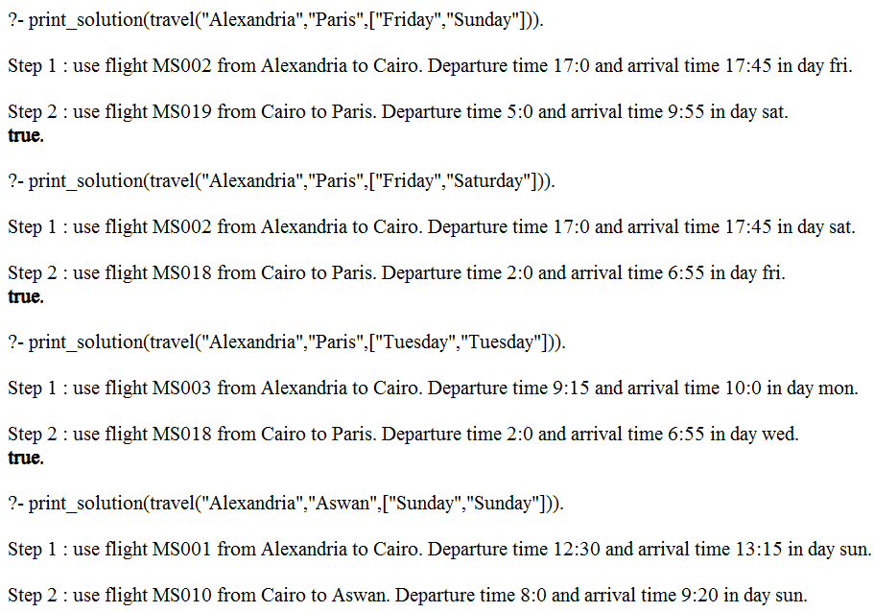

**Test Case 2:**



**Test Case 3:**



**Test Case 4:**



**Test Case 5:**

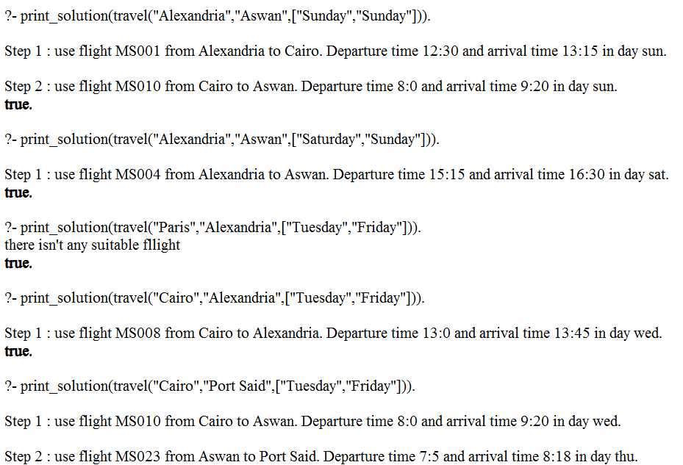

**Test Case 6:**



**Test Case 7:**



**Test Case 8:**



**Test Case 9:**

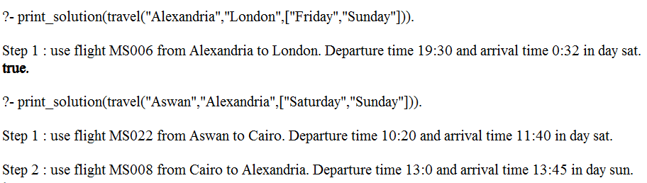

**Test Case 10:**

